Spring Proposal

Patrick Landy
Brian Webb
Jarell Williams
Jaron Zadi

December 4, 2007

Spring Semester Project Scope
Assemble and implement the concept design established from the fall semester, produce a fully functional (and improved staking process) and provide a template for future implementation on several machines.

Cost Analysis
The main goal of this project is to be able to change the existing staking machine efficiently without costing the company a lot of money. The chuck is the biggest expense out of all the items needed to make this change over complete. One of the major decisions we made as a group for the new staking station was to use an existing staking machine that’s currently used in the plant today. By making this decision we save the company money, due to the fact that, the company currently owns several of these chucks. Each chuck cost approximately $900 to machine not including the materials needed to build it and is sold for about $4300.00.
The cylinder is the next major component of our design that has already been purchase for $40.00 from Fabco-Air. In addition, we saved the company additional money on hoses that are used to drive the cylinder because the cylinder chosen for this project will be compatible with the existing hoses already on the machine. The only other component that needs to be purchase is the flow control fittings for the hoses. Purchasing the flow controls fittings for $25.00, instead of the regular fittings for $10.00 would be worth the extra money because we will be able to control the air flow to the cylinder. This will allow us to fine tune the cylinder so that it would produce a more accurate stroke to the part. The total cost amount needed to make this project work will be $90.00 because the company currently owns several of these chucks. In addition, the hoses needed for the cylinder exists on the machine already. If this design was to be implemented on other roller finger follower machines in the plant it would cost the company $ 5306.00.

Item | Description | Company | Quantity | Price per Item | Total Price
Cylinder | Pancake cylinder- ¾” bore and ½” stroke | Fabco-Air Cylinder | 1 | $40.00 | $40.00
Hoses | ¼” OD x 1/8”ID poly tubing | McMaster | 2 | $8.00 | $16.00
Fittings | Flow control type NPT to Tubing | McMaster | 2 | $25.00 | $50.00
Machining Hours | Rohm Chuck | N/A | 1 | $900.00 | $900.00
Chuck | Rohm Chuck | N/A | 1 | $4300.00 | $4300.00
Total Cost |  |  |  |  | $5306.00

Spring Schedule
In order to properly organize the next phase in developing a new staking tool, a new set of goals were established. Among the goals are a newly redesigned project scope which is modified for the upcoming tasks as well as a detailed schedule which notes estimated time frames of completion as well as milestones to be completed along the way.
The spring schedule is an estimate and it is assumed that the dates and guidelines set forth will be adjusted throughout the semester. This is expected because the design team is working around the company in order to not slow down production times. The schedule is design for flexibility and takes into account cancellations due to line machine failures. During this down time the team will discuss and implement different ways to keep moving despite unexpected scheduling conflicts.

Implementation
The entire project takes place over two semesters with the first half consisting of concept design and the second as implementation. With the concept design now completed, the implementation makes up the second half of the project. This portion of the project will consist of many iterations and corrections to the existing design. A diagram of the expected schedule is shown below.
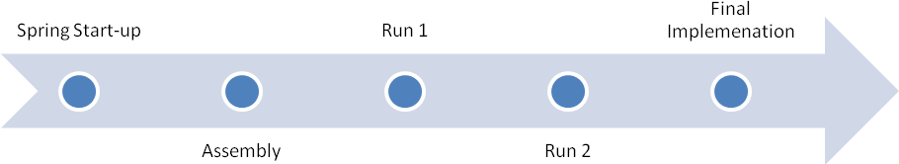
Figure 1: Spring Schedule (Summary)

The spring start-up is a short amount of time allowed in the beginning of the semester that will allow the team to check for all available parts, order new parts and discuss scheduling changes. After having all of the parts and confirming with the sponsors that the team may advance on to the next step the team will begin the assembly phase.
The assembly has multiple subsections that are interrelated, many of which cannot be accomplished without certain prerequisite assemblies. To save time during assembly, machining will happen simultaneously. After the assembly is complete the team will present the assembled project to the sponsors and confirm installation.
The installation makes up the majority of the iterations (three in total). There will be three runs in total separated by adjusted designs and improvements to the existing design. During the third and final run, the design will not be taken off of the machine. At this point the final step of the process will include creating a design packet that documents the entire process from beginning to finish which includes a method of implementing on other machines in the future.

Testing Criteria
In order to determine the success or failure of the design a list of criteria and checkpoints will be established. Although this criteria is heavily dependent on the needs assessment originally established by the sponsors, a few additional criteria will be established throughout the testing process. The criteria will further break down the needs assessment in order to analyze specifics about the process such as the quality of staking, cost of maintenance and an in-depth analysis of the improved staking design versus the old staking design.

Spring Gannt Chart

